**F22-3738 | F22-3661**

SQE

Assignment03

**1. Introduction** 1

• **Overview of the Project’s Purpose** 1

**2. Technologies Used** 1

• **Node.js** 1

• **Jest for Testing** 1

• **Docker for Containerization** 1

**3. Functionalities Implemented** 1

• **Detailed Description of Each Main Feature** 1

• **Interaction Between Components** 1

**4. File Structure** 1

• **Brief Description of Each Directory and Its Contents** 1

**5. Project Setup** 2

• **Step-by-step Instructions** 2

• **Prerequisites** 2

• **Installation of Dependencies** 2

**6. Running the Application** 2

• **Commands to Start the Application** 2

• **Environment Configuration Needed** 2

**7. Docker Setup** 2

• **Instructions on Building and Running the Project Using Docker** 2

**8. Testing** 3

• **How to Run Tests Using Jest** 3

• **Description of What Each Test Suite Covers** 3

• **HTML Jest Reporting** 3

**9. Additional Documentation and Resources** 3

• **Links to External Documentation or Resources Used** 3

• **Any Scripts or Utilities Described** 3

**10. Conclusion** 3

• **Summary of the Project** 3

• **Potential Future Work or Improvements** 3

**Screenshots and Additional Content** 3

• **After “Introduction” and “Functionalities Implemented** 3

• **After “Project Setup** 4

• 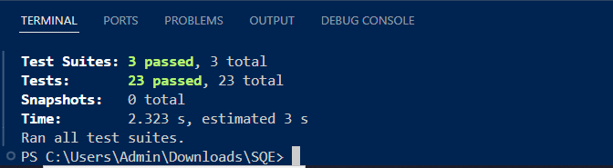**In the “Docker Setup** 4

• **After the “Testing** 5

• **Setup Video** 6

# **1. Introduction**

* **Overview of the Project’s Purpose**: This section should articulate the core objectives and goals of the project. Explain the problem it solves or the need it addresses. **High-level Features and Functionality**: Provide an overview of the key features and functionalities of the project. This might include the main operations, user interactions, or automated tasks the project performs.

# **2. Technologies Used**

* **Node.js**: Mention the version of Node.js used and its role in the project as the runtime environment.
* **Jest for Testing**: Describe how Jest is utilized for testing the application’s functionalities.
* **Docker for Containerization**: If Docker is used, explain its role in ensuring that the application runs consistently across different environments.

# **3. Functionalities Implemented**

* **Detailed Description of Each Main Feature**: Enumerate and explain each main feature of the application. Describe how these features interact with the user or other systems.
* **Interaction Between Components**: If applicable, describe how different parts of the application interact with each other. This could include data flow, API interactions, or internal service communication.

# **4. File Structure**

* **Brief Description of Each Directory and Its Contents**: Describe what each directory contains and its role in the project. For instance, src might contain the source code, tests the test files, and node_modules the dependencies.

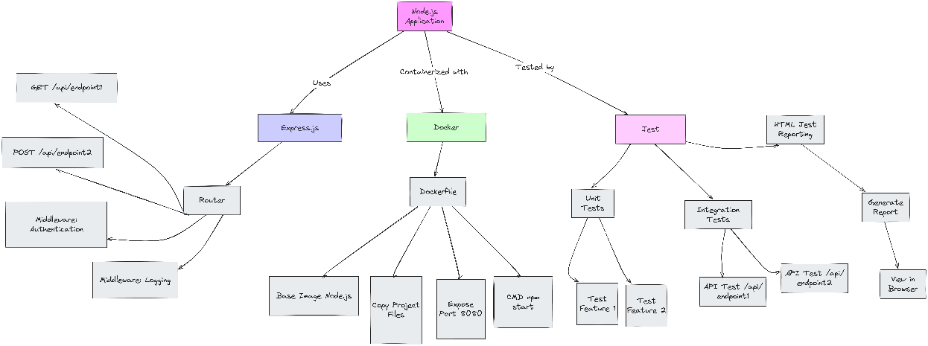

# **5. Project Setup**

* **Step-by-step Instructions**: Guide the user through setting up the project environment after cloning the repository.
* **Prerequisites**: List prerequisites such as Node.js version, any global packages that need to be installed beforehand.
* **Installation of Dependencies**: Provide commands to install necessary dependencies:

npm install

# **6. Running the Application**

* **Commands to Start the Application**: Provide the exact command to start the application, usually:

npm start

* **Environment Configuration Needed**: Discuss any environment setups, such as setting up environment variables or config files.

# **7. Docker Setup**

* **Instructions on Building and Running the Project Using Docker**:
  + **Dockerfile Explanation**: Explain the purpose of each instruction in the Dockerfile.
  + **Commands**:
  + docker build -t your-app-name .
  + docker run -p chosen_port:app_port your-app-name
  + **Accessing the Application**: Instructions on how to access the application running inside a Docker container.

# **8. Testing**

* **How to Run Tests Using Jest**: Provide the command to run the tests:

npx jest or npm test

* **Description of What Each Test Suite Covers**: Explain the purpose of each test file or test suite.
* **HTML Jest Reporting**: Guide on how to generate and view HTML reports from Jest testing.

# **9. Additional Documentation and Resources**

* **Links to External Documentation or Resources Used**: Provide URLs or references to documentation or resources that were utilized.
* **Any Scripts or Utilities Described**: If there are any utility scripts or tools, describe them here.

# **10. Conclusion**

* **Summary of the Project**: Summarize the project’s purpose, features, and what was achieved.
* **Potential Future Work or Improvements**: Suggest areas for further development or additional features that could enhance the project.

# **Screenshots and Additional Content**

* **After “Introduction” and “Functionalities Implemented”**:

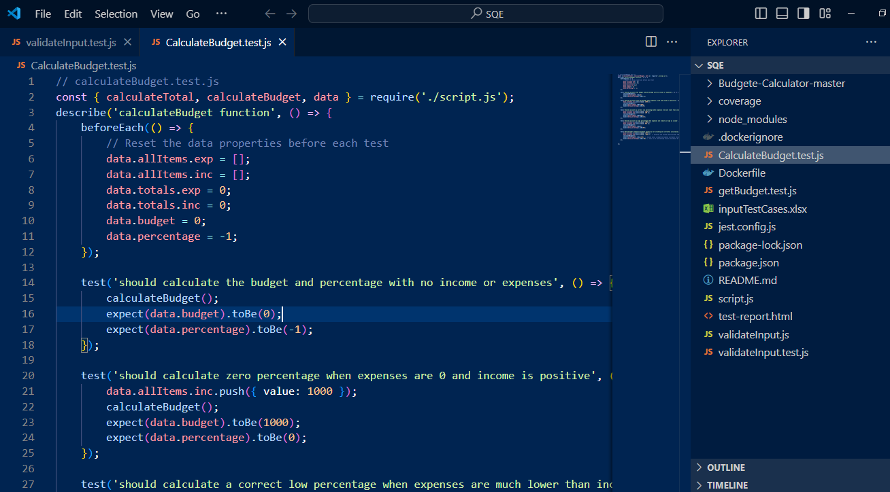

* **After “Project Setup:**
* **In the “Docker Setup” section**:

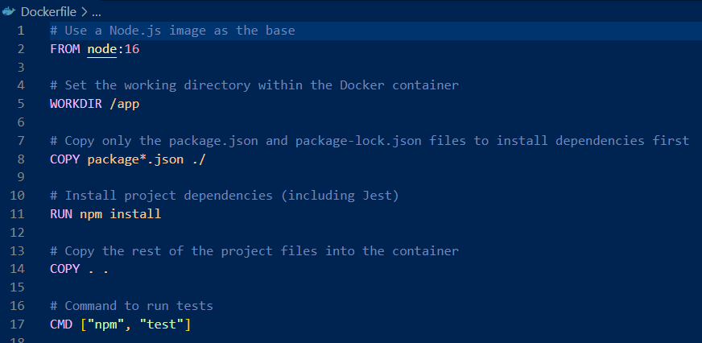

* **After the “Testing” section**:

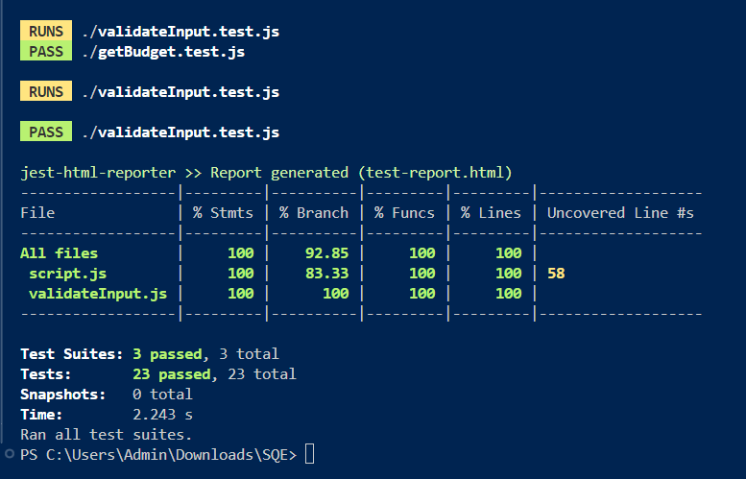

**Video and Extra Documentation**

* **Setup Video**:

